<https://www.w3schools.com/graphics/game_sound.asp>

<https://www.codespeedy.com/how-to-set-a-background-music-on-a-web-page/>

<https://stackoverflow.com/questions/61444507/javascript-add-background-audio-to-game>

(Check if the autoplay is enabled in the browser). !! IMPORTANT

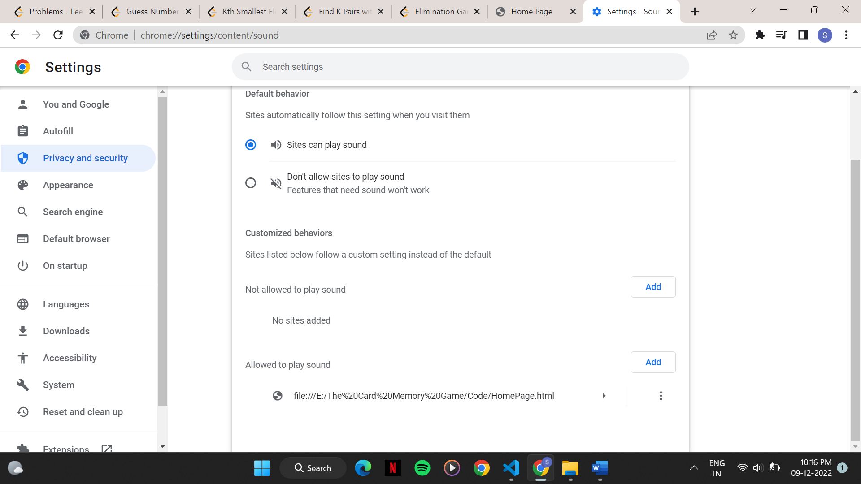

In chrome, settings -> privacy and security -> site settings -> additional content setting (sound) -> allowed to play sound (add URL’s).

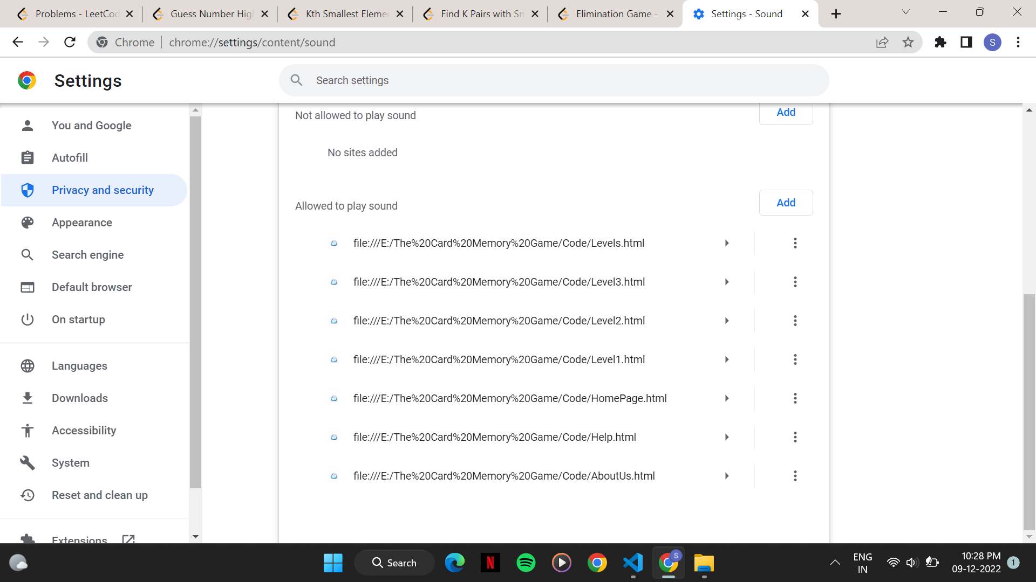

Favicons added….small blue colour logos just on the left side of the tab name when opened.